Unti 1
Online services 1
Communication Services:
When we talk about communication services, we are talking about any online method of sharing and transferring data between different people.
Common types of communication services include the following:
- Email
- Instant messaging
- News groups
- Social networking
- Web conferencing
- Blogs
Types of Communication Services:
Email:
Short for electronic mail, this lets us send written messages instantly to other side of the world using the internet. This is much quicker then using traditional mail.
Instant Messaging:
This allows us to have private written conversations with an individual or a group of people. It’s a grate way of organizing meetings with group of friends and is cheaper then a phone call.
Newsgroups:
These are similar to modern-day internet forums and are used to discuss topic and share ideas
Unlike instant messaging, newsgroups are public. Anyone accessing the newsgroup can read the messages that have been posted.
Social Networking:
Websites like twitter or Facebook allow us to share our thoughts, opinions and pictures quickly with all of our friends and family.
This helps us keep in touch with our wider friendships groups, whom we might otherwise lose contact with
Web Conferencing:
Software like skype allows us to talk with people via voice or video call, so you can see them as your’re talking.
This is fantastic way of keeping in touch with friends and family who live abroad and much cheaper than an international phone call, too.
Blogs:
Short for Web logs, these are web pages that are regularly updated used as a public online journal.
Vlogs, or Video Logs, are similar but are done through video, and they usually use sites such as YouTube to share and recive comments.
Real-Time Information Services:
Real-time-information services are used to get the lates, up to date information on a particular topic.
Common types of real-time information services include:
- Train timetables
- News services
- Traffic reports
- Flight status updates
- Weather reports

Online services 2
Online advertising
Online advertising is made to capture and hold peoples attention to promote a service or product. There are multiple ways in which this can be used.
Company like H&M can pay google money so that when a person searches for a specific product there product comes to the top that is called a paid for link. Another point to make is that the google logo are registered trademarks of google inc, used with permission.
Pay Per click (ppc) advertising
This is quite and effective model of advertising as the host website for this example Atrnos have a load of pop up adds and banners everywhere and if the user clicks them then he will go to that site and Atrnos make some money from that as each time a user clicks it Atrnos make money for hosting.
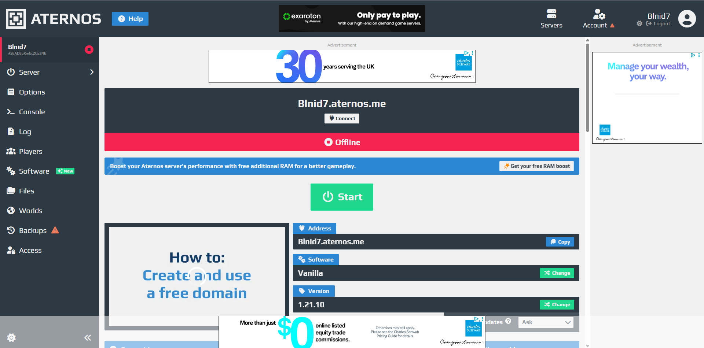

65 = 1000001
34 = 10011
1110011 =
1011010 =
1 2 4 8 16 32 64 128:

